Humanoid Reinforcement Learning

Overview
For this project, I picked the MUJOCO humanoid environment as it relates to my current career in orthopedics research as well as my background in exercise science and human physiology. I wanted an environment that felt somewhat applicable, especially for understanding how things like inertial measurement unit (IMU) systems work on the back end and how simulations can be created to mimic real human movement.

Approach
I used Proximal Policy Optimization (PPO) as the reinforcement learning (RL) model for this with the overall goal of getting the humanoid to walk forward without falling. After some research into what RL models are used for robotics training and IMU based visualizations for research purposes, I found that PPO seems to be a more stable model that is a bit simpler to implement than other models such as a Deep Deterministic Policy Gradient algorithm. The reward structure for this PPO model basically reinforces not falling, and if the torso posture moves outside a certain threshold, that counts as failure. The model also lets you set different numbers of training iterations, so I experimented with a range of learning steps to see if improved how far I could get the humanoid to move without falling.
I trained the model using Stable Baselines 3 PPO model and changed the learning duration from:
- 200,000 steps
- 400,000 steps
- 800,000 steps
- 1.5 million steps
For each of these, I plotted line graphs of performance and also exported GIF recordings of the humanoid to visualize how well it learned to walk. I also looped all the videos together for a fun music overlay since I think the outputs look somewhat ridiculous and comical.

Results
As I increased the number of learning steps, the humanoid definitely improved and was able to move farther forward with more stability, but even at higher step counts the humanoid barely moved. The biggest issue I noticed was with the lower extremity knee joints and hip flexion/extension. Getting the model to consistently create realistic knee flexion and extension seemed to be the biggest limitation where there was a lot of upper extremity and torso motion but was limited throughout the lower body. This issue may have been resolved with even more training steps, but the 1.5 million already took a long time to run. However, this issue with lower body movement somewhat mirrors real-world biomechanics in a way where human gait is complex and one of the last physical motion patterns children learn. This is due to the relationships between the skeletal muscle systems, force interactions with the external environment, and all the anatomical variability across humans.
200,000 Steps
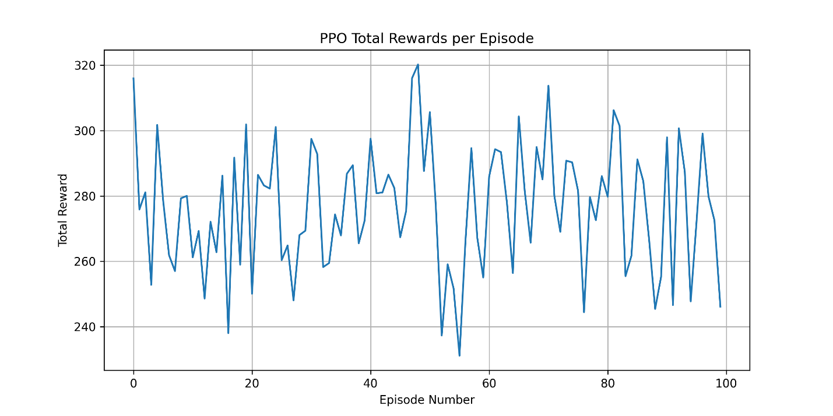
400,000 Steps
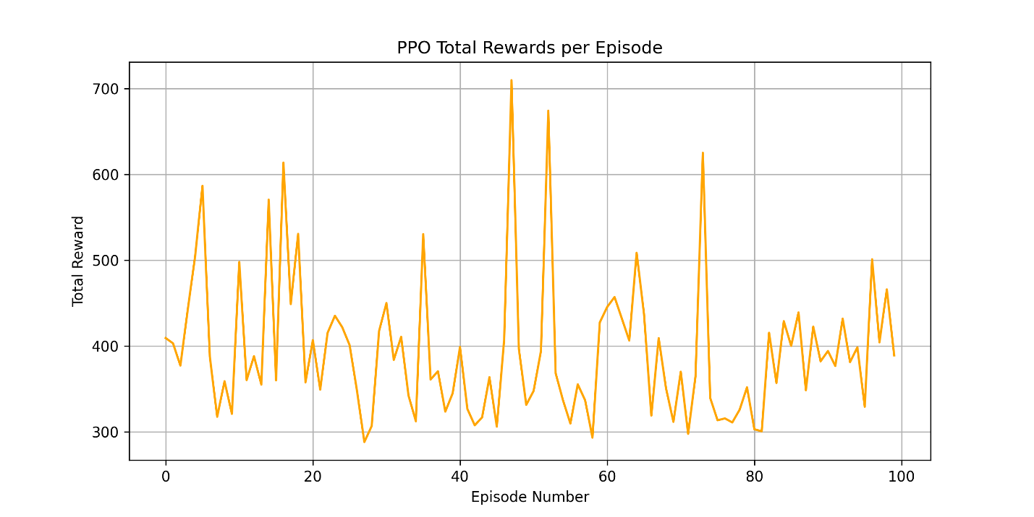

800,000 Steps
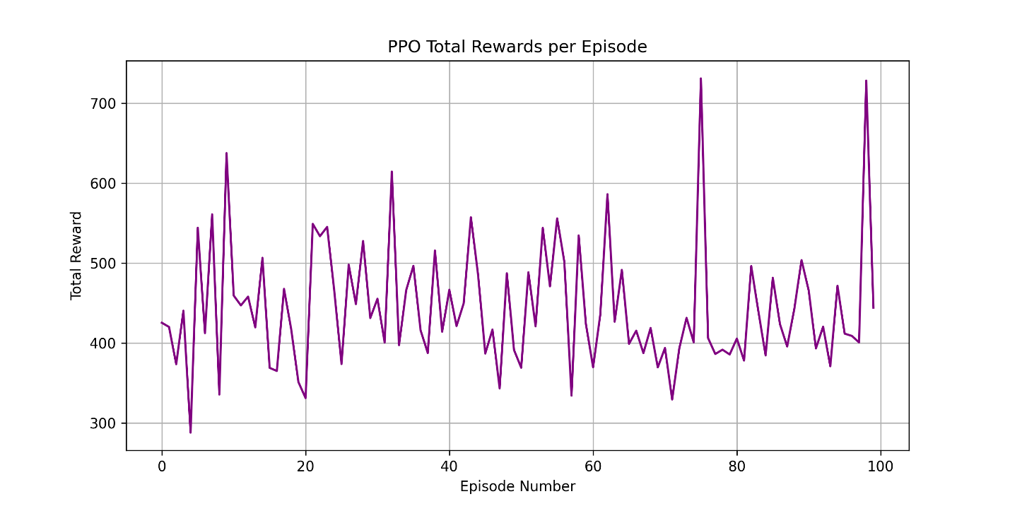
1,500,000 Steps
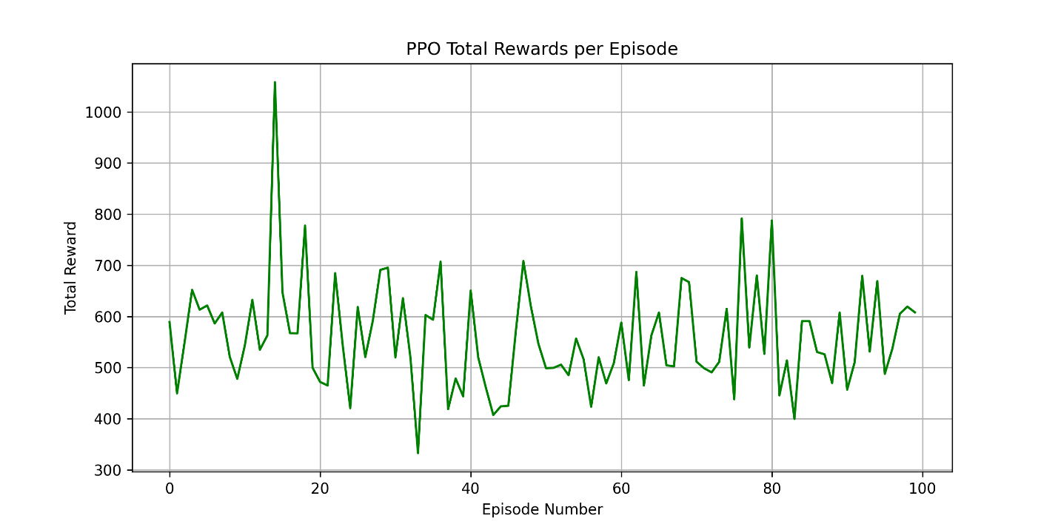
Basically what these performance graphs show is that as the number of training steps increases the humanoid shows a bit more stability and higher rewards, which can also be visualized by the progression of the 4 GIFs. Again, from a real-world perspective these results aren’t surprising as time and more learning steps are required for even human children to learn to walk and perform optimal locomotion.

Conclusion
This whole project was interesting from a biomechanics perspective and gave me a better sense of how robotics and simulations try to replicate human movement and why it’s so hard. It also relates into how IMU and motion-tracking setups are used in research, and how much nuance there is in getting accurate, human-like motion out of a model. Overall, I thought this was a really cool project to use reinforcement learning with real-world human movement concepts although I wasn’t fully able to get the model to produce a successful walking motion. It made me appreciate how difficult it is to model gait both in robotics and in biomechanics research, and how much room there is for improvement in simulating human-like movement patterns. Video-based AI analysis of human movement (force, velocity, joint angles, etc) has been a hot topic in my field of research, although I am curious of how long it will take to accurately predict biomechanical without data from external markers on a participant.

References
- https://www.geeksforgeeks.org/deep-learning/reinforcement-learning-in-robotics/
- https://www.geeksforgeeks.org/machine-learning/what-is-reinforcement-learning/
- https://stable-baselines3.readthedocs.io/en/master/modules/ppo.html
- https://gymnasium.farama.org/environments/mujoco/humanoid/
- https://spinningup.openai.com/en/latest/algorithms/ddpg.html
- https://spinningup.openai.com/en/latest/algorithms/ppo.html
- https://link.springer.com/article/10.1186/s12984-021-00919-y
- https://pypi.org/project/ImageIO/
- https://github.com/openai/gym
- https://www.geeksforgeeks.org/machine-learning/types-of-reinforcement-learning/#policybased-reinforcement-learning
- https://github.com/openai/gym/blob/master/gym/envs/mujoco/humanoidstandup_v4.py
- https://www.geeksforgeeks.org/python/create-and-save-animated-gif-with-python-pillow/
- https://www.youtube.com/watch?v=FVw8hkolBgM
- https://www.youtube.com/watch?v=QwJcF08hfs8

